Law Enforcement Academy

The purpose of the Vernon College Law Enforcement Academy is to serve the needs of the law enforcement community within our service area and to provide students with the basic knowledge and skills set forth in the 736 hour Basic Peace Officer Course. Our Academy is 744 hours; classes are generally from 6:00 pm. - 10:00 pm. Monday through Friday and all day on various Saturdays.

The Academy will be held on the Wichita Falls Campus STC, 2813 Central Freeway E. Wichita Falls, Texas. Emphasis throughout the Academy is placed on the learning objectives set forth in the curriculum by the Texas Commission on Law Enforcement. All Academies licensed by the Texas Commission on Law Enforcement cover the material put forth in the mandated 643 hour curriculum.

If you have questions after reviewing the Application Packet, please contact Mike Hopper at 940 689-7190. The Academy packet must be complete and turned into Mike Hopper for reviewed prior to registration. Need based scholarships are available for those who qualify.
If you need assistance in filling out the application, please contact Mike Hopper at 940 689-7190.
In accordance with Commission regulations, the Basic Peace Officer course shall consist of a minimum of 696 classroom hours.

Academy Topics
Introduction and Orientation
1. Professionalism and Ethics
2. Professional Policing
3. Fitness and Wellness, and Stress Management
4. TCOLE Rules
5 Multiculturalism and Human Relations
6. Racial Profiling
7. U.S. & Texas Constitutions, Bill of Rights, and Criminal Justice System
8. Penal Code
9. Code of Criminal Procedure
10.Arrest, Search, and Seizure
11. Asset Forfeiture
12. Identity Crimes
13. Consular Notification
14. Civil Process
15. Health and Safety Code – Controlled Substances Act
16. Alcoholic Beverage Code
17. Family Violence and Related Assaultive Offenses
18. Missing & Exploited Children
19. Child Alert Check List
20. Victims of Crime
21. Human Trafficking
22. Traffic
23. Intoxicated Driver (SFST)
Mechanics of Arrest
24. Written Communication
25. Verbal Communication/Public Interaction
26. Spanish
27. De-Escalation Strategies
28. Force Options
29. CIT
30. Traumatic Brain Injury
31. Arrest & Control
32. Criminal Investigations
33. Juvenile Offenders
34. Professional Police Driving
35. Patrol Skills
36. Radio Communications
37. Civilian Interaction Training
38. Interacting with Deaf & Hard of Hearing
39. Canine Encounters
40. Emergency Medical Assistance
41. Firearms
42. HazMat Awareness/ICS
43. ALERRT 1

Application can also be found at…
http://www.vernoncollege.edu/police-academy
Requirements
High school diploma or, high school equivalency certificate or, an honorable discharge from the armed forces of the United States after at least 24 months of active duty service, is fingerprinted and is subjected to a search of local, state and U.S. national records and fingerprint files to disclose any criminal record
Has never been on court-ordered community supervision or probation for any criminal offense above the grade of a Class B misdemeanor or a Class B misdemeanor within the last ten years from the date of the court order.
Has never been convicted of an offense above the grade of a Class B misdemeanor or a Class B misdemeanor within the last ten years.
Has never been convicted of any family violence offense.
No felony conviction.
Is not prohibited by state or federal law from operating a motor vehicle.
Is not prohibited by state or federal law from possessing firearms or ammunition.
Is a U.S. citizen. 21 Years old by graduation
Vernon College Law Enforcement Academy
744-HOUR BASIC PEACE OFFICER COURSE
Step into your future
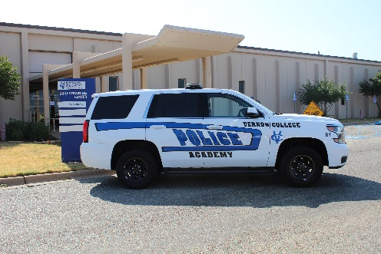

New Class Starts September 2024
Requirements posted in June 2024 on web site: www.vernoncollege.edu/police-academy
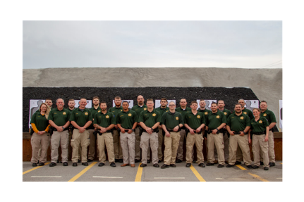
Class of 2019
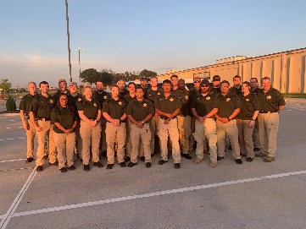
Class of 2020
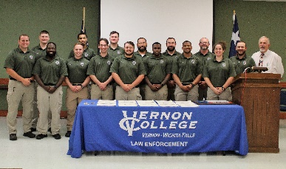
Class of 2021
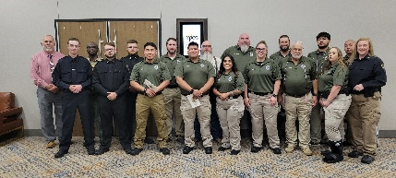
Class of 23-24

2024 Gradutes
Nicole Adams
David Bersick
Tanner Bohannon
Derek Bolf
Demetrius Crandall
Natalie Garcia
Christopher Hogan
Bailee Lawson
Jesus Lora
Marcus Martinez
Hayden Patterson
Sidronio Rangel
Amanda Reyes
Luis Rico
Jim Tidwell
Preston Turner
Glen Whitfield

For more information about graduation rates, median loan debt, program costs, and placement rates, visit www.vernoncollege.edu.

